**PRACTICAL – O5**

**AIM:**

Implementation of Basic R Commands.

**THEORY:**

* R is a language and environment for statistical computing and graphics.
* It is a GNU project which is similar to the S language and environment which was developed at Bell Laboratories (formerly AT&amp;T, now Lucent Technologies) by John Chambers and
* colleagues.
* R can be considered as a different implementation of S.
* There are some important differences, but much code written for S runs unaltered under R.
* R provides a wide variety of statistical (linear and nonlinear modelling, classical tests, time-series analysis, classification, clustering ...) and graphical techniques, and is highly extensible.
* The S language is often the vehicle of choice for research in statistical methodology, and R provides an Open Source route to participation in that activity.
* One of R’s strengths is the ease with which well-designed publication-quality plots can be produced including mathematical symbols and formulae where needed. Great care has been taken over the defaults for the minor design choices in graphics, but the user retains full control.
* R is available as Free Software under the terms of the Free Software Foundation’s GNU General Public License in source code form. It compiles and runs on a wide variety of UNIX platforms and similar systems (including FreeBSD and Linux), windows and MacOS.

**CODE & OUTPUT:**

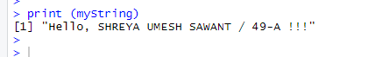

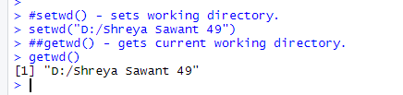

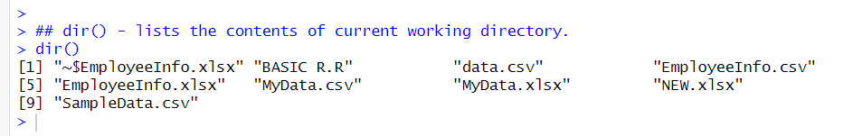

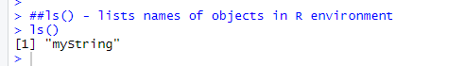

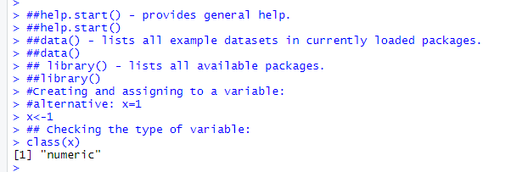

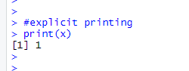

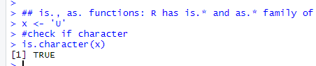

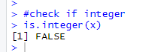

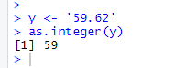

**###Creating Vector: contains objects of same class.**

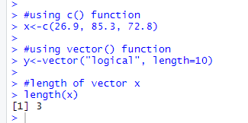

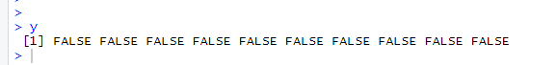

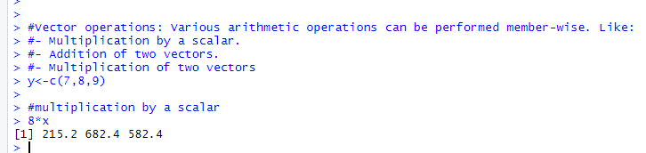

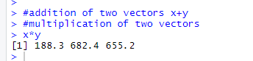

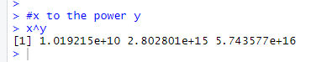

**###Creating Matrix: Two-dimensional array having elements of same class.**

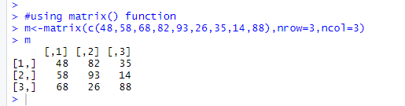

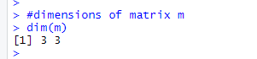

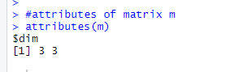

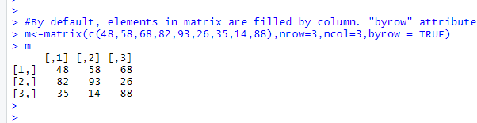

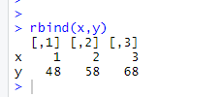

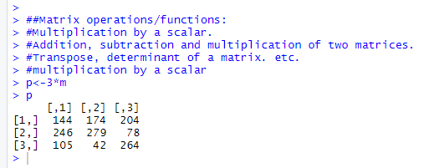

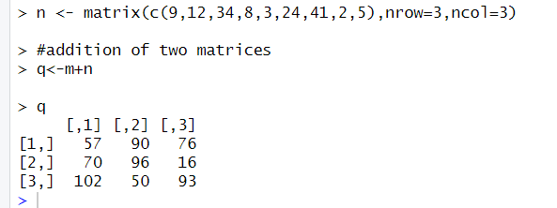

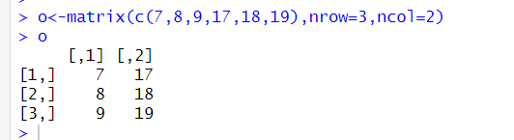

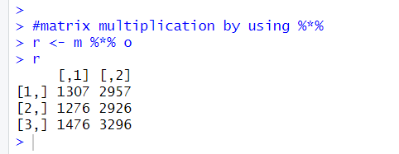

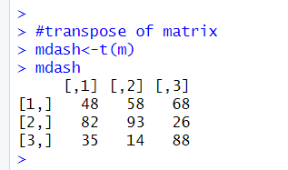

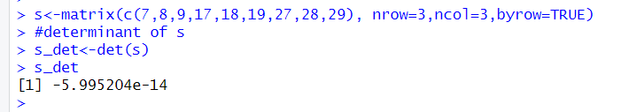

**###List: A special type of vector containing elements of different classes. ####Elements of list can be accessed by giving element index or name in [[]].**

**###Factor: Represents categorical data. Can be ordered or unordered.**

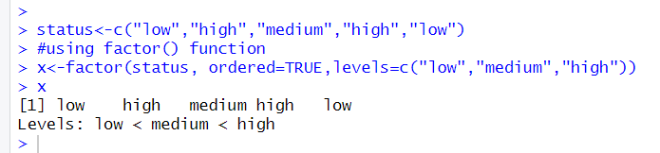

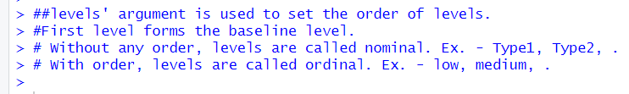

**###Data frame: Used to store tabular data. Can contain different classes.**

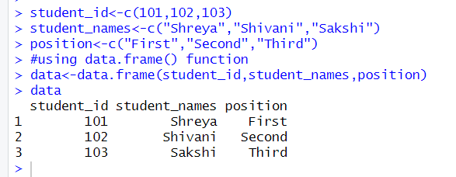

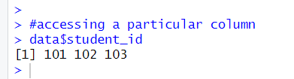

**###Table command is used to create a 2dimensional table in R**

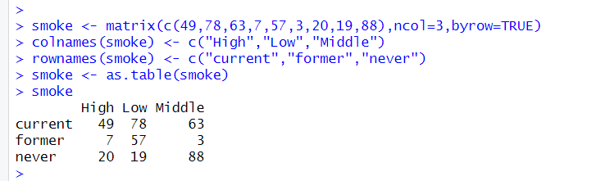

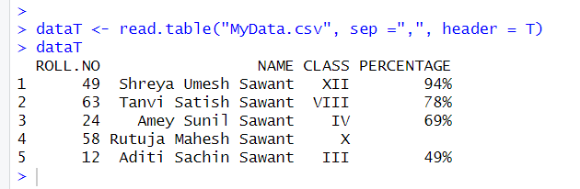

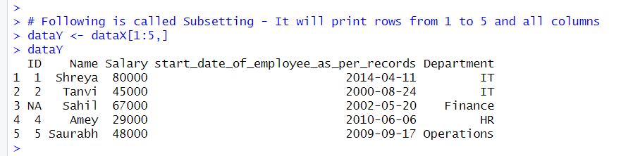

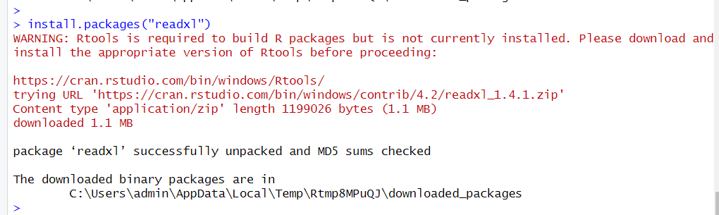

**CONCLUSION:**

In this practical I learnt the implementation of basic R commands.